# Experiment 1

## Overview and Fundamentals of Unix(Linux) Operating System.

### Introduction to Operating Systems

An operating system (OS) is the program that, after being initially loaded into the computer by a **boot program**, manages all of the other application programs in a computer. Operating System lies in the category of system software. It basically manages all the resources of the computer. An operating system acts as an interface between the software and different parts of the computer or the computer hardware. The operating system is designed in such a way that it can manage the overall resources and operations of the computer. 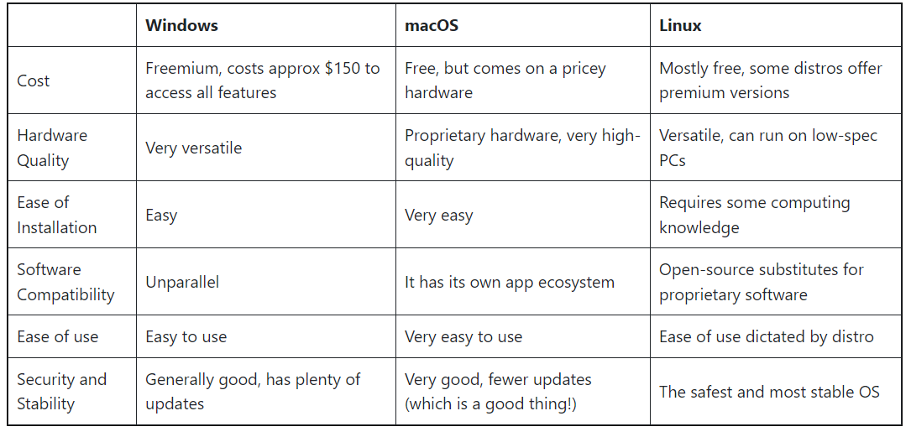

## 

## Unix Operating System

Unix is a powerful and versatile operating system that originated in the late 1960s by **Ken Thompson and Dennis Ritchie** at Bell Labs. It was designed to provide a flexible and stable computing environment. Unix has been the foundation for many other operating systems, including Linux and macOS. Its principles and design have had a profound influence on the development of modern computing systems.

#### Features:

1. **Multi User:** Unix supports multiple users working on the same system simultaneously. Each user can have their own account, files, and processes.

2. **Multitasking:** It allows multiple processes to run concurrently, giving the appearance that they are all executing at the same time.

3. **Multiplatform:** Unix is highly portable and can run on various hardware architectures. This portability has led to its adoption on a wide range of devices, from supercomputers to embedded systems.

4. **Hierarchical File System:** Unix organizes files in a hierarchical directory structure, which allows for easy organization and management of files and directories.

5. **Command Line Interface (CLI):** Unix primarily uses a text-based command-line interface for interaction. This allows users to perform tasks by typing commands rather than relying on graphical interfaces.

6. **Modularity:** Unix is composed of small, specialized utilities that perform specific tasks. These utilities can be combined using pipes and filters to accomplish more complex operations.

7. **Shell:** The shell is the command interpreter that provides a user interface for interacting with the Unix system. There are different shells available, such as Bash, C-shell, and Korn shell, each with its own features and syntax.

8. **Networking Capabilities:** Unix was designed from the ground up with networking in mind. It includes a suite of networking tools and protocols that allow for seamless communication between Unix systems and with other types of systems.

9. **Security:** Unix has a robust security model, including user authentication, file permissions, and access control lists, which helps protect system resources and data.

10. **Stability and Reliability:** Unix systems are known for their stability and robustness. They can run for long periods of time without needing to be restarted.

11**. Open Standards and Compatibility:** Unix adheres to open standards, which means that software developed for one Unix system can often run on another Unix system without modification.

12. **Extensibility:** Unix supports the development of custom software through its rich set of programming tools and libraries, making it a popular choice for software development environments.

13. **Scripting and Automation:** Unix provides powerful scripting capabilities that allow users to automate tasks and create custom workflows using shell scripts and other scripting languages.

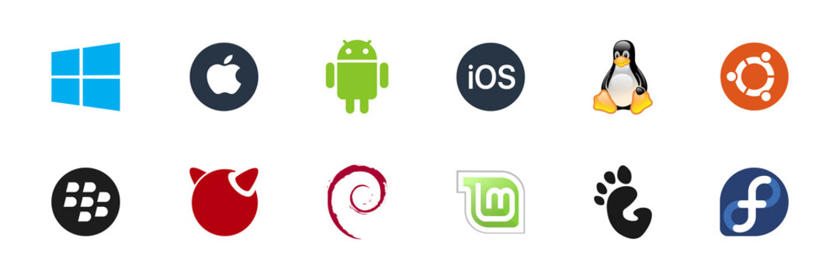

# Experiment 2

## Installation of Virtual -Box and Ubuntu Operating System

**What is VirtualBox ?**

VirtualBox is a powerful x86 and AMD64/Intel64 **virtualization** product for enterprise as well as home use. Not only is VirtualBox an extremely feature rich, **high-performance** product for enterprise customers, it is also the only professional solution that is freely available as **Open Source Software** under the terms of the GNU General Public License (GPL) version 3. Presently, VirtualBox runs on Windows, Linux, macOS, and Solaris hosts and supports a large number of guest operating system including but not limited to Windows (NT 4.0, 2000, XP, Server 2003, Vista, Windows 7, Windows 8, Windows 10), DOS/Windows 3.x, Linux (2.4, 2.6, 3.x and 4.x), Solaris and OpenSolaris, OS/2, and OpenBSD.

____________________________________________________________________________________________________

**Installation of Virtual Box**

Download and install Oracle VirtualBox from the official website: **virtualbox.org**

Download the Ubuntu ISO image from the official website: **ubuntu.com**

1. **Create a New Virtual Machine:** Open VirtualBox and click the "New" button. Provide a name for your virtual machine, select "Linux" as the type, and choose the appropriate version (usually "Ubuntu (64-bit)"). Click "Next."

2. **Allocate Memory:** Choose how much RAM you want to allocate to the virtual machine. Ubuntu generally requires at least 2GB for smooth operation. You can allocate more if your host system has enough resources. Click "Next."

3. **Create a Virtual Hard Disk:** Choose the "Create a virtual hard disk now" option and click "Create."

4. **Virtual Hard Disk File Type:** Choose the default "VDI (VirtualBox Disk Image)" and click "Next."

5. **Storage on Physical Hard Disk:** You can choose between "Dynamically allocated" (which will grow as needed) or "Fixed size" (which will be a fixed size on your host system). Choose one and click "Next."

6. **File Location and Size**: Choose the location to save the virtual hard disk file and specify its size. At least 20-30GB is recommended for Ubuntu. Click "Create."

7. **Configure Settings:** In the VirtualBox manager, select your newly created virtual machine and click on "Settings." Here, you can configure various options such as processor cores, video memory, etc.

8. **Mount Ubuntu ISO:** In the "Settings" window, go to the "Storage" tab. Under the "Controller: IDE" section, click the icon that looks like a CD/DVD and choose "Choose a disk file." Select the Ubuntu ISO you downloaded.

9. **Start the Virtual Machine:** Click "OK" in the "Settings" window. Then, start the virtual machine by selecting it and clicking the "Start" button.

10. **Install Ubuntu:**The virtual machine will boot from the Ubuntu ISO. Follow the on-screen instructions to install Ubuntu. You'll need to select language, keyboard layout, and installation type. You can choose to install updates and third-party software during the installation process.

11. **Partitioning:** When prompted, choose the installation type. You can either erase the disk and install Ubuntu or choose "Something else" for manual partitioning.

12. **Complete Installation:** Follow the remaining steps to set up your user account, password, and system settings. Once the installation is complete, the virtual machine will restart.

13. **Install VirtualBox Guest Additions (Optional):** After Ubuntu is installed, it's recommended to install VirtualBox Guest Additions for better integration and performance. You can do this by selecting "Devices" in the VirtualBox menu of the running virtual machine window and choosing "Insert Guest Additions CD image."

# Experiment 3

## Architecture of Unix(Linux) Operating System.

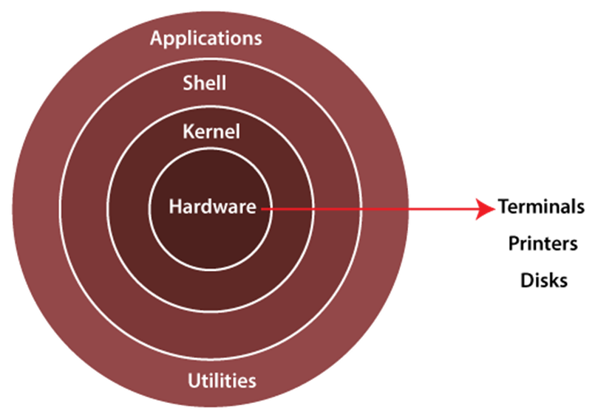

The Linux operating system's architecture mainly contains some of the components: **the Kernel, System Library, Hardware layer, System,** and **Shell utility**.

**1. Kernel:-** The kernel is one of the core sections of an operating system. It is responsible for each of the major actions of the Linux OS. This operating system contains distinct types of modules and cooperates with underlying hardware directly. The kernel facilitates required abstraction for hiding details of low-level hardware or application programs to the system. There are some of the important kernel types which are mentioned below:

* Monolithic Kernel
* Micro kernels
* Exo kernels
* Hybrid kernels

**2. System Libraries:-** These libraries can be specified as some special functions. These are applied for implementing the operating system's functionality and don't need code access rights of the modules of the kernel.

**3. System Utility Programs:-** It is responsible for doing specialized level and individual activities.

**4. Hardware layer:-** Linux operating system contains a hardware layer that consists of several peripheral devices like CPU, HDD, and RAM.

**5. Shell:-** It is an interface among the kernel and user. It can afford the services of the kernel. It can take commands through the user and runs the functions of the kernel. The shell is available in distinct types of OSes. These operating systems are categorized into two different types, which are the **graphical shells** and **command-line shells**. The graphical line shells facilitate the graphical user interface, while the command line shells facilitate the command line interface. Thus, both of these shells implement operations. However, the graphical user interface shells work slower as compared to the command-line interface shells.

______________________________________________________________________________________________________________

**Advantages of Linux**

1. The main advantage of Linux is it is an open-source operating system. This means the source code is easily available for everyone and you are allowed to contribute, modify and distribute the code to anyone without any permissions.
2. In terms of security, Linux is more secure than any other operating system. It does not mean that Linux is 100 percent secure; it has some malware for it but is less vulnerable than any other operating system. So, it does not require any anti-virus software.
3. The software updates in Linux are easy and frequent.
4. Various Linux distributions are available so that you can use them according to your requirements or according to your taste.
5. Linux is freely available to use on the internet.
6. It has large community support.
7. It provides high stability. It rarely slows down or freezes and there is no need to reboot it after a short time.
8. It maintains the privacy of the user.
9. The performance of the Linux system is much higher than other operating systems. It allows a large number of people to work at the same time and it handles them efficiently.
10. It is network friendly.
11. The flexibility of Linux is high. There is no need to install a complete Linux suit; you are allowed to install only required components.
12. Linux is compatible with a large number of file formats.
13. It is fast and easy to install from the web. It can also install on any hardware even on your old computer system.
14. It performs all tasks properly even if it has limited space on the hard disk.

**Disadvantages of Linux**

1. It is not very user-friendly. So, it may be confusing for beginners.
2. It has small peripheral hardware drivers as compared to windows.

# Experiment 5

## Programs on Linux Console (TryHackMe)

1. **echo:** Output text that we provide.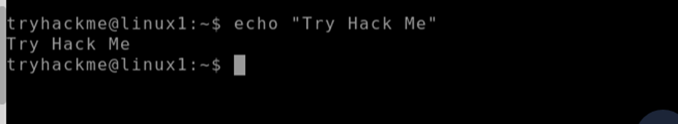

1. **whoami:** Find’s what user we're currently logged in as.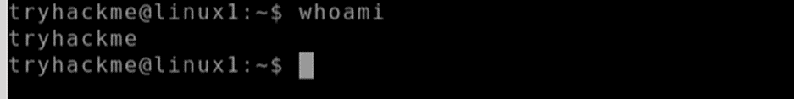
2. **ls:** Listing files in current directory. Before we can do anything such as finding out the contents of any files or folders, we need to know what exists in the first place. This can be done using the "**ls**" command (short for listing).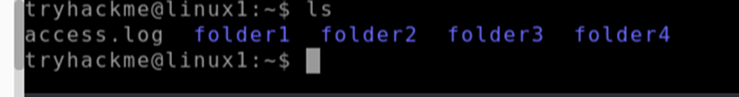
3. **mkdir:** For adding new directories.

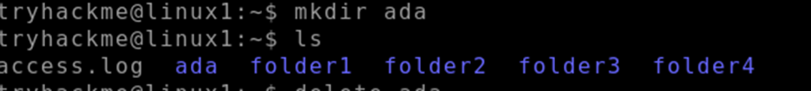

1. **rmdir:** For removing directories.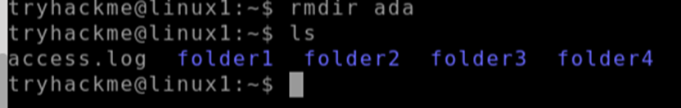
2. cat: Read the contents of the file.

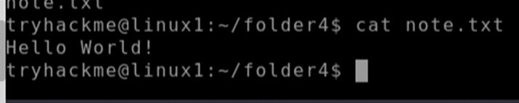

1. **man:** Know all related commands using **man (**function**/**command_name**)**.

